Project 2

<Hazard>

CIS 5- 41202

David

Duran

Due Date: 02/11/16

Introduction:

**Hazard** is an early [English](https://en.wikipedia.org/wiki/England) game played with two [dice](https://en.wikipedia.org/wiki/Dice); it was mentioned in [Geoffrey Chaucer](https://en.wikipedia.org/wiki/Geoffrey_Chaucer)'s *Canterbury Tales* in the 14th century.

Despite its complicated rules, hazard was very popular in the 17th and 18th centuries and was often played for money. At [Crockford's](https://en.wikipedia.org/wiki/Crockford%27s) Club in London, hazard was especially popular. In the 19th century, the game [craps](https://en.wikipedia.org/wiki/Craps) developed from hazard through a simplification of the rules. Craps is now very popular in North America but neither game remains popular amongst the rest of the world.

Rules:

Players 2+

Age range Adult

Setup time < 1 minute

Random chance High, Dice rolling

Skill(s) required Betting

Rules: Any number may play, but only one player – the **caster** – has the dice at any one time.

In each round, the caster specifies a number between 5 and 9 inclusive: this is the **main**. He then throws two dice.

* If he rolls the main, he wins (**throws in** or **nicks**).
* If he rolls a 2 or a 3, he loses (**throws out**).
* If he rolls an 11 or 12, the result depends on the main:
  + with a main of 5 or 9, he throws out with both an 11 and a 12;
  + with a main of 6 or 8, he throws out with an 11 but nicks with a 12;
  + with a main of 7, he nicks with an 11 but throws out with a 12.
* If he neither nicks nor throws out, the number thrown is called the **chance**. He throws the dice again:
  + if he rolls the chance, he wins;
  + if he rolls the main, he **loses** (unlike on the first throw);
  + if he rolls neither, he keeps throwing until he rolls three times without getting one or the other, winning with the chance, losing with the main, and losing without getting either.

FlowChart

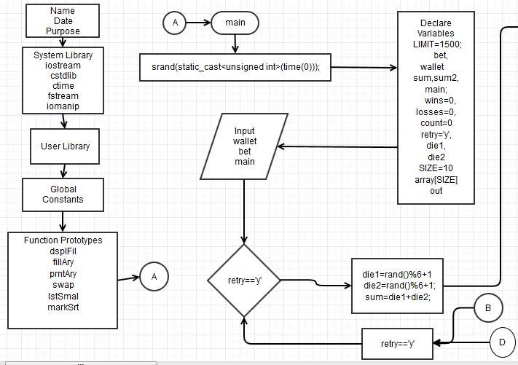

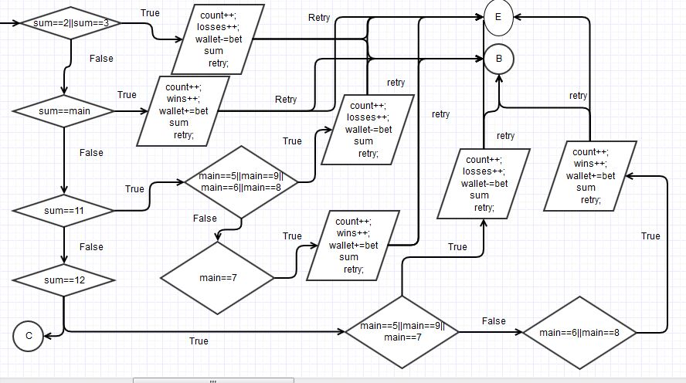

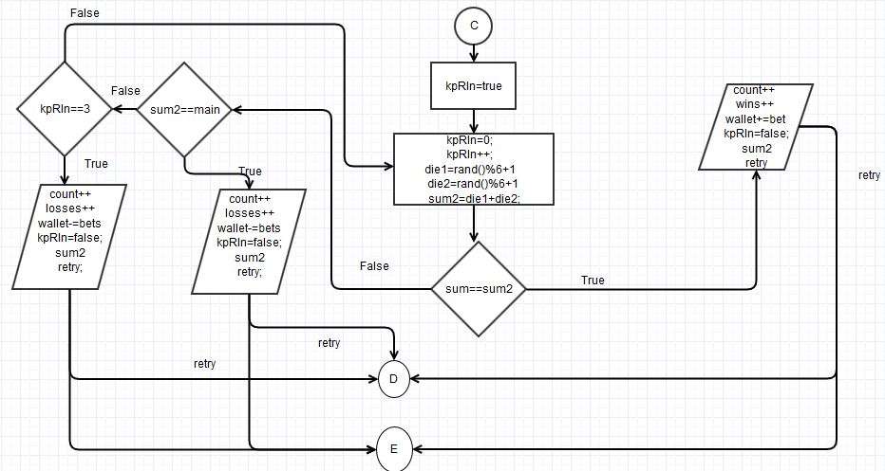

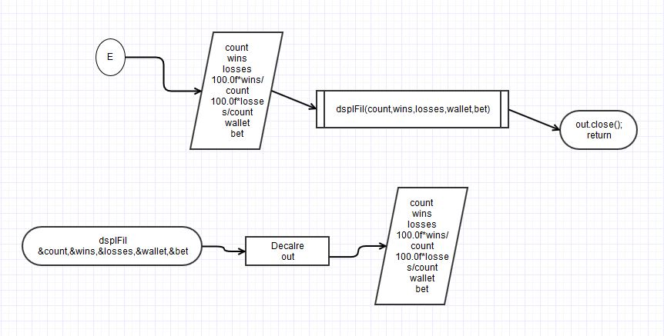

Pusedo Code

/*

File: main.cpp

Author: David Duran

Created on February 02, 2016, 06:06 PM

Purpose: Hazard

*/

//System Libraries

//I/O

//srand and rand function

//time to set the random number seed

//File I/O

//Formatting

//User Libraries

//Global Constants

//Function Prototypes

// Execution Begins Here

//Set the random number seed

//Declare and initialize variables

//Limit of $$ able to put on table

//Amount $ able to bet and Amount on user

//Main = #5-9, sum=die1+die2, sum2=die1+die2

//Number of Wins, Losses, and Games

//Dice #1: 1-6,Dice #2: 1=6,Replay

//Allows the File to be read

//Hazard Game Setup

//Limits the amount able to bet

//Throw Dice

//Fill the array with random 2 digit numbers

//Print the array

//Test finding the smallest number in the list

//Print the array

/******************************************************************************/

/* Display File */

/******************************************************************************/

//loop and fill the array with random numbers

/******************************************************************************/

/* Void 2 */

/******************************************************************************/

//loop and fill the array with random numbers

/******************************************************************************/

/* Swap Variables */

/******************************************************************************/

/******************************************************************************/

/* Smallest in List */

/******************************************************************************/

//Loop and compare

/******************************************************************************/

/* */

/******************************************************************************/

//loop and fill the array with random numbers

|  |  |  |
| --- | --- | --- |
| Variables | Data Types | Location |
| LIMIT | Const unsigned int | 28,43 |
| bet | Float | 29 |
| wallet | Float | 29 |
| sum | Unsigned int | 30 |
| sum2 | Unsigned int | 30 |
| main | Unsigned int | 30 |
| wins | Unsigned short | 31 |
| losses | Unsigned short | 31 |
| count | Unsigned short | 31 |
| retry | Char | 32 |
| die1 | Char | 32 |
| die2 | Char | 32 |
| out | ofstream | 33,186 |
| kpRln | Bool | 115 |
| Info | Ofstream | 201 |

CheckList

Srand 29

Data Types:int,float,string,short,char,const,ofstream,bool 31-38,115,245

If statement: 44,62,79,97

Else if statement:70,78,87,96,105,114

Do-While:51,116,246

For Statement:222,248

Switch:122

While:58,153

Ternary Statement:55

Setprecision:159

System Libraries:9-13

Function:184,200,220,230,243

Array:37

Sources:

1. <https://en.wikipedia.org/wiki/Hazard_%28game%29>